Wound Busters Clinic ppt presentation Melbourne 2016.

Primary health care with General practice at the core, has a vital role in assessment, prevention and management of chronic wounds. There is a high prevalence of chronic wounds in primary care with General Practitioners being involved in the care of around 86% of patients with a leg ulcer and community nurses spending up to 50% of their time treating leg ulcers. There are significant challenges to the implementation of evidence based wound management in primary care, particularly in the areas of education, skills and access to expert advice.(Yelland 2014)

Graves and Zheng estimated the total cost of venous leg ulcer management in 2010-11 in both hospital and residential Australian care settings to be US$802.55 million and the direct costs of all types of chronic wounds to be US$2.85 billion, equivalent to 2% of the total National health expenditure.

This paper reviews the establishment of a collaborative complex wound clinic (a secondary tier) in a primary health care setting to address these challenges. The clinic was established in early 2012 to fill a local need on the Gold Coast identified by the Carramar report [2009] and to fill a national need as identified by BEACH data (2012,2014), These results illuminated low diagnoses, low referral patterns and antibiotic use. Data provided by the Coast Vascular Clinic displayed the demographics of 140 patients seeking management for their wounds over a 2-year period. Note (Tables 1-4) Chronic diseases related to aging are certainly leading to the increased numbers of patients with chronic wounds on the Gold Coast due to the large retiree population.
Table 1 Patient age distribution. Table 2 Wound Eitiology
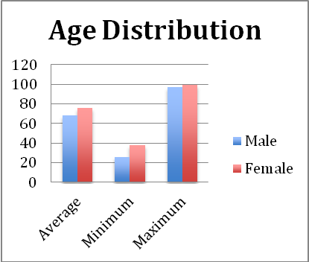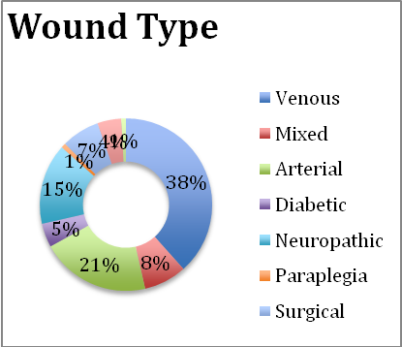
Table 3 Common Co morbidities Table 4 Duration of Wounds.
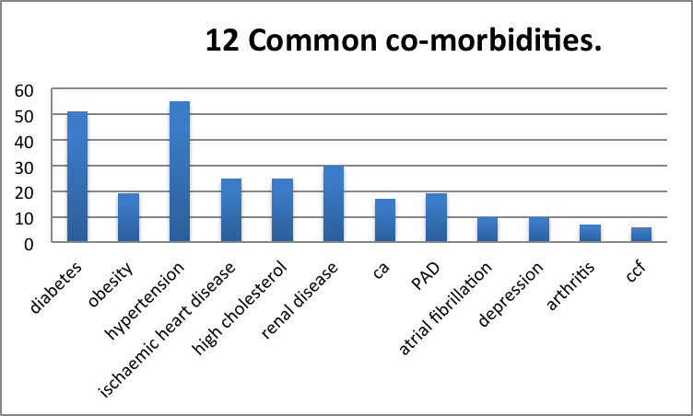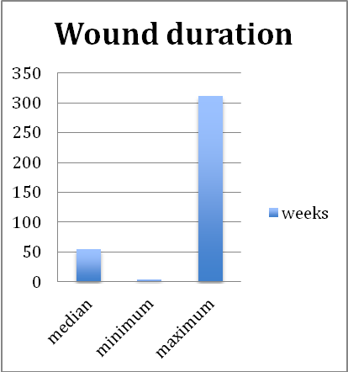

Innovative integrated management plans were developed by Vascular Nurse Practitioner Nicola Morley from the Gold Coast University Hospital. Guidelines for referral processes were developed in collaboration with Vascular Surgeons, Renal Physicians and Infectious Diseases Physicians. Standardised management plans were developed for the secondary tier ensuring comprehensive assessment, evidence based diagnosis related care plans, benchmarking and prompt referral. Chronic diseases linked with chronic wounds require close collaboration of many specialist teams. Note Table 3, which highlights the 12 common co-morbidities of patients presenting to a tertiary Medical Service for the Management of Wounds. Note Table 5 to review the surgical interventions required to optimally manage this complex cohort of patients referred to the Gold Coast University Hospital Vascular Clinic.

Table 5
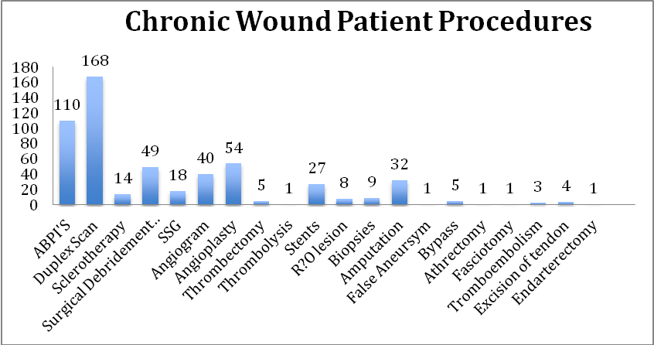

The goals of the clinic were to:
- Establish a secondary level of wound management utilising nurse led evidence based medicine, antibiotic stewardship, governance and advanced therapies.
- Provide access to community patients based on a referral system from primary care providers, in particular General Practitioners.
- Provide education and practical skills to GPs and Practice Nurses.
- Collaborate with the Gold Coast University and Robina Hospitals to manage complex wounds within the community to reduce out-patients attendances and admissions
- Replicate the Wound Busters model of care Nationally.

The Wound Busters clinic was established in early 2012. In 2013 a partnership was formed with Healthscope, Wound Busters Pty Ltd and Gold Coast Primary Health Network to provide a multifaceted program of education-both theory and clinical skills development through clinical mentoring through the Clinic. The education of GP nurses is ongoing and has been expanded to include GP education programs as well. The expansion of the Clinic to include nurses from other agencies as well as a broader range of allied health professionals led to the formation of a supportive medical peer group and a supportive patient group enabling all of the patients to listen, interact, encourage and learn from others’ clinical experiences both positive and negative.

Documentation and evaluation practices include weekly measurement of size, photography and wound bed assessment relating to the TIME acronym. The establishment of the wound clinic to mentor other General Practices on the Gold Coast has led to the successful replication of our practices to promote greater collaboration with other General Practices, the Public Health Service as well as Private Hospitals. The layering of such an efficient clinic with a practice nurse education program has proven that aspects of the Wound Busters model can be translated into any general practice setting leading to prompt assessment at the primary tier, prompt referral to the secondary tier and reduced numbers of patients requiring referral to the tertiary tier and/or hospital admission as emergency cases.

The Chronic Disease-Wound Management Education Project was funded by Queensland Health and managed by the Gold Coast Medicare Local. The Wound Management Innovation Cooperative Research Centre provided in kind support to evaluate the program, provide educational support and prepare a report.

The results and anecdotal feedback from participating nurses demonstrate that this Wound Busters education program significantly increased participants’ confidence and knowledge in wound management and had a major impact on their clinical practice. Participants also rated this form of education intervention within a wound clinic based in a GP Practice very highly. Here they received a combination of knowledge transfer, skill transfer and hands on and observation opportunities. The results also support the chosen methods of providing education, with 95% or more liking or strongly liking face-to-face training and professional support methods such as coaching or mentoring.

It was recommended at the time of the evaluation 9 (Innes Walker K et al 2013)
that this model of wound management education and training be expanded and promoted to other Medicare Locals as well as other relevant organisations. Medicare Locals do not exist any longer with PHN s having taken their place.
The Clinic developed into a secondary tier clinic in collaboration with the Integrated Care Project between the Medicare Local and Queensland Health. The clinic was used to manage wounds with advanced technologies in the primary health sector such as topical negative pressure and low frequency gravity fed ultrasonic debridement, compression bandaging and off loading devices.
The expertise and skills of the staff and resources in the clinic resulted in a number of interesting outcomes:
- The management of a diverse range of complex wounds that normally would not be managed in General Practice. [see case studies below]
- The Gold Coast region, and other areas of Australia, is in need of a secondary level wound clinic as evidenced by referrals coming from a wide geographical area from central and Northern NSW to Brisbane and other areas of SE Queensland.
- Referrals from a variety of Specialists for assistance with management of wounds, especially in the area of ultrasonic debridement and application of compression bandaging.
- Collaboration with Private Hospitals to provide inpatient wound services.

The Clinic used the Debriflo UWI as the ultrasonic debridement device of choice as the saline solution is gravity fed; the device does not require expensive consumables, i.e. saline pump or vacuum. The device is comparable to the MIST device but is able to be used with both contact and non-contact application. The frequency of the Debriflo UWI ranges between 35-45 kHz, which is known as a long wave. Long wave ultrasonic application relies upon the long waves taking the aerosolised bubbles into the dermis rather than a pump. Serena T et al, have shown that gravity fed, non-contact 40khz was shown to penetrate to the depths of 3.5mm of healthy pig dermis. The lower the kHz setting the deeper the length of the wave and hence the deeper the penetration of the solution into the unhealthy dermis. Lam K et al and Williams et al have shown that gravity fed, 35kHz ultrasonic debridement operates with low aerosolisation. It is recommended that fluid containment be also developed according to each work environment.

The Clinic accepted patients with complex wounds from a variety of Clinical Specialities:
Plastic Surgeons.
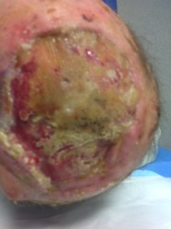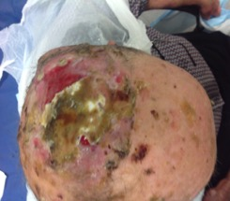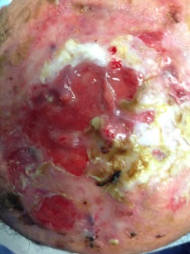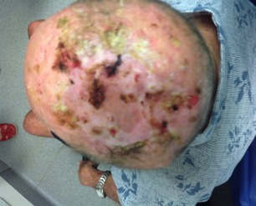

Vascular Surgeons.
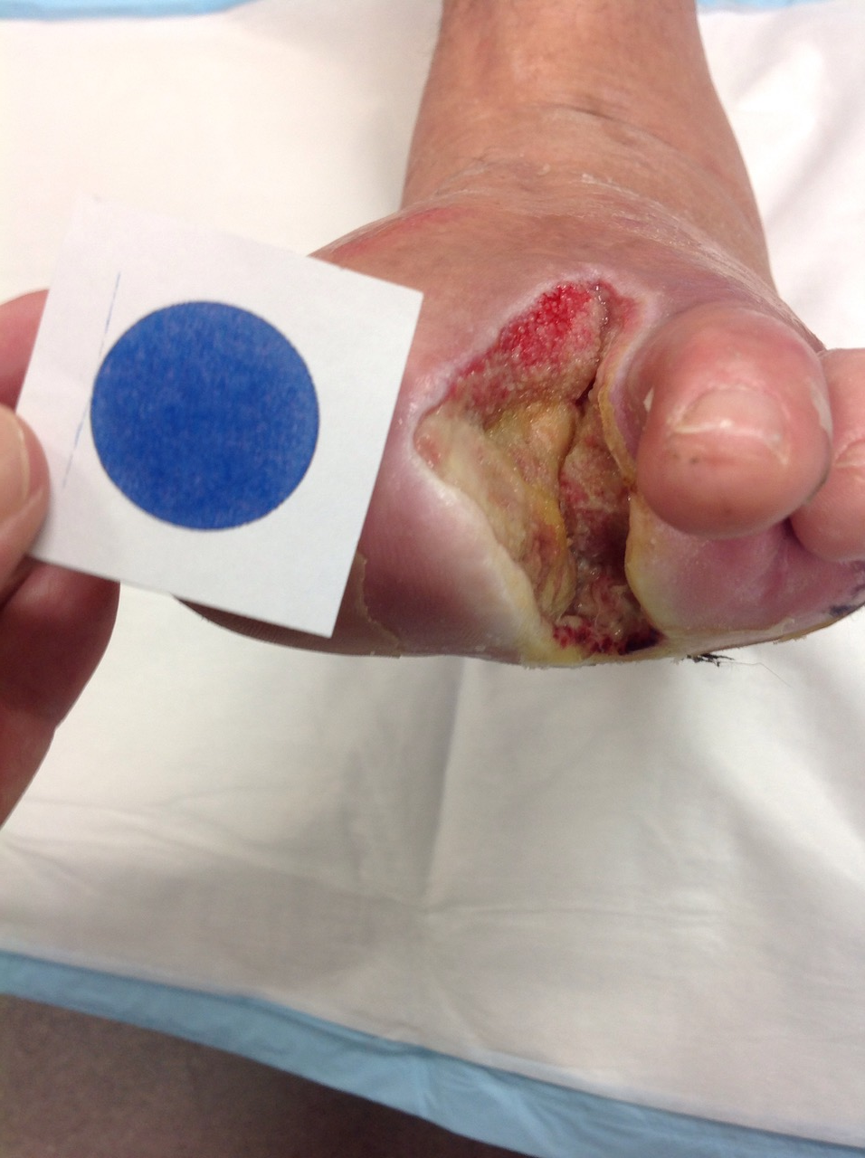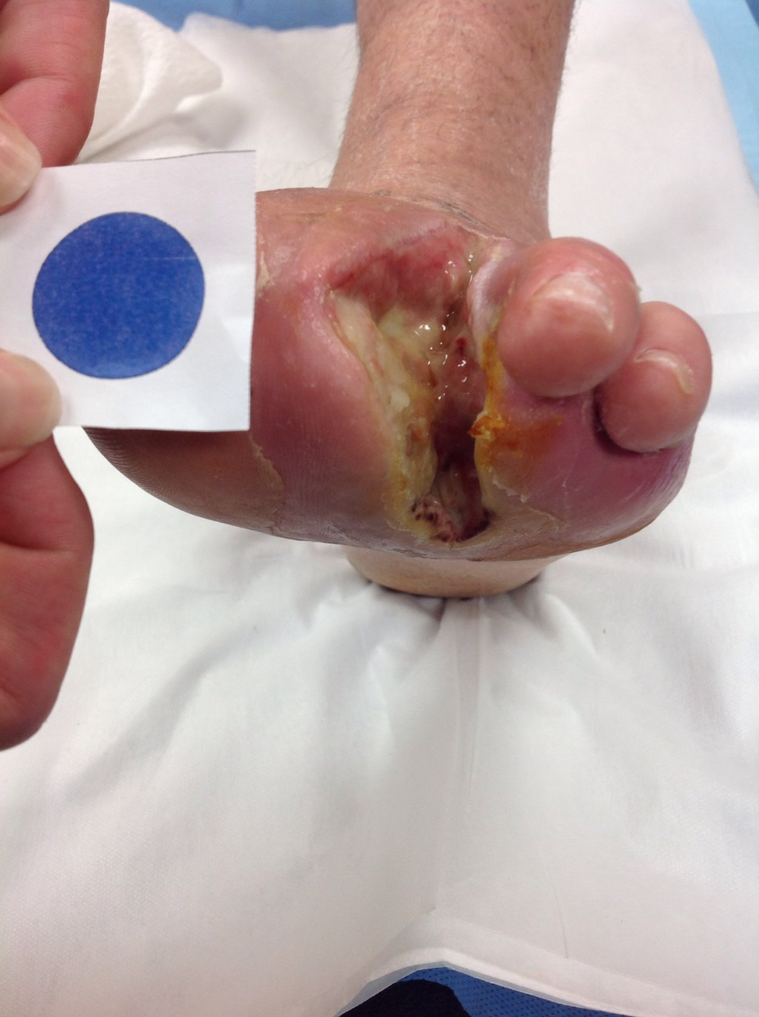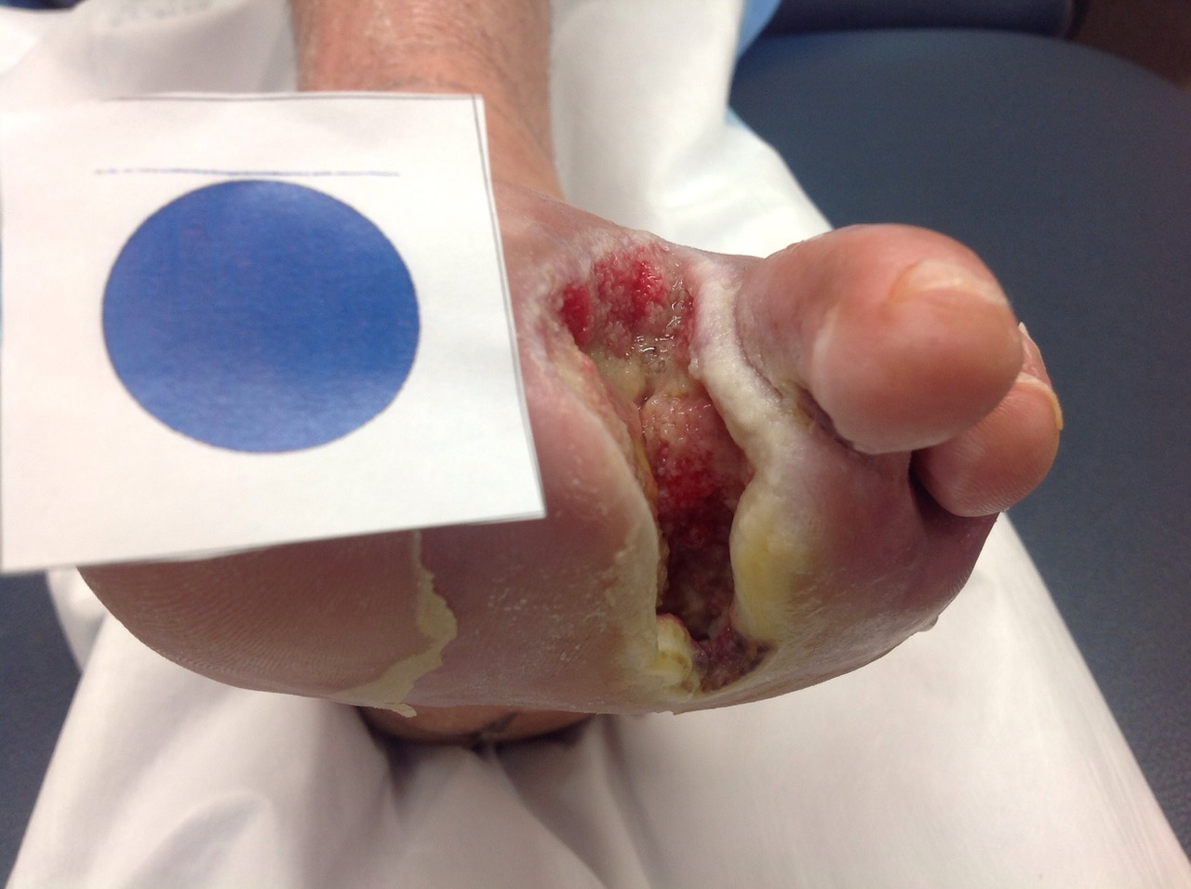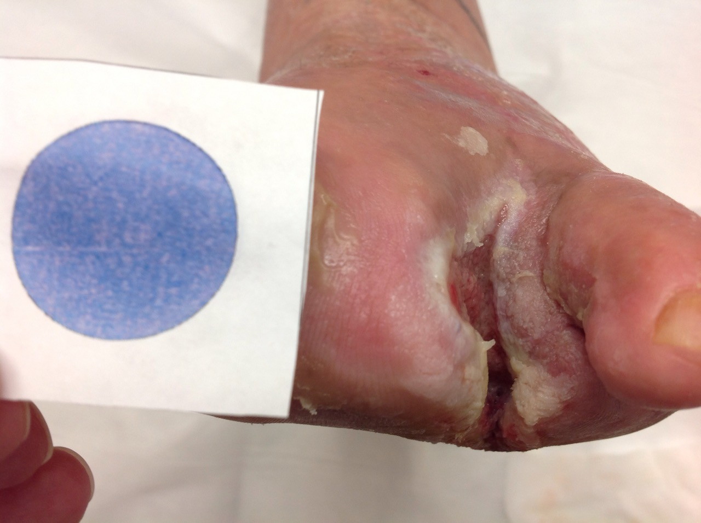

Nurse Practitioner Vascular

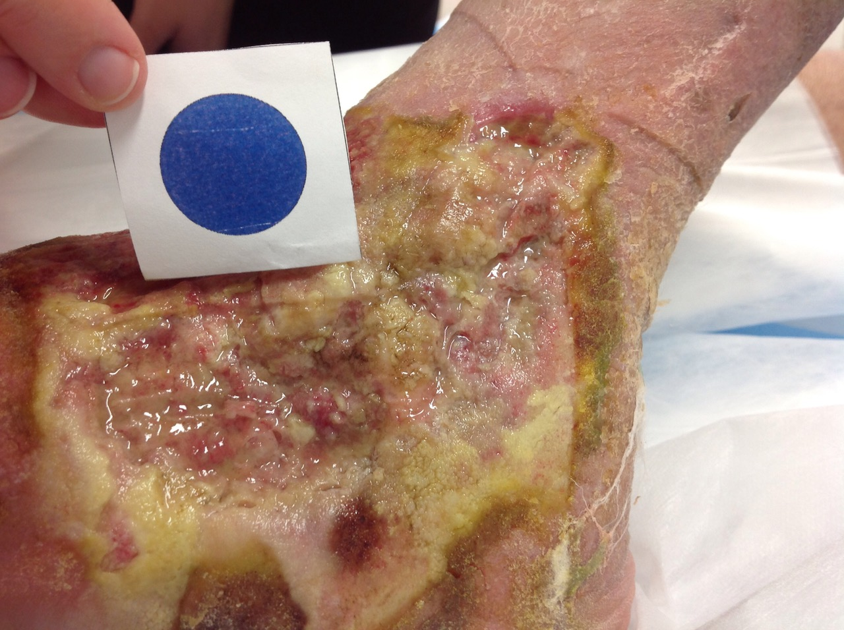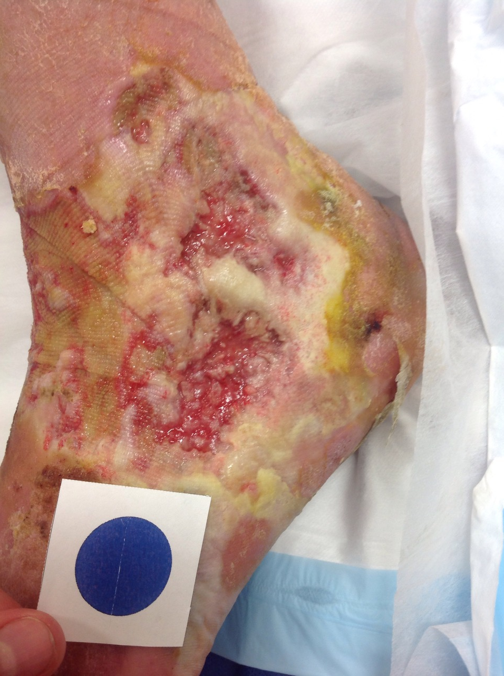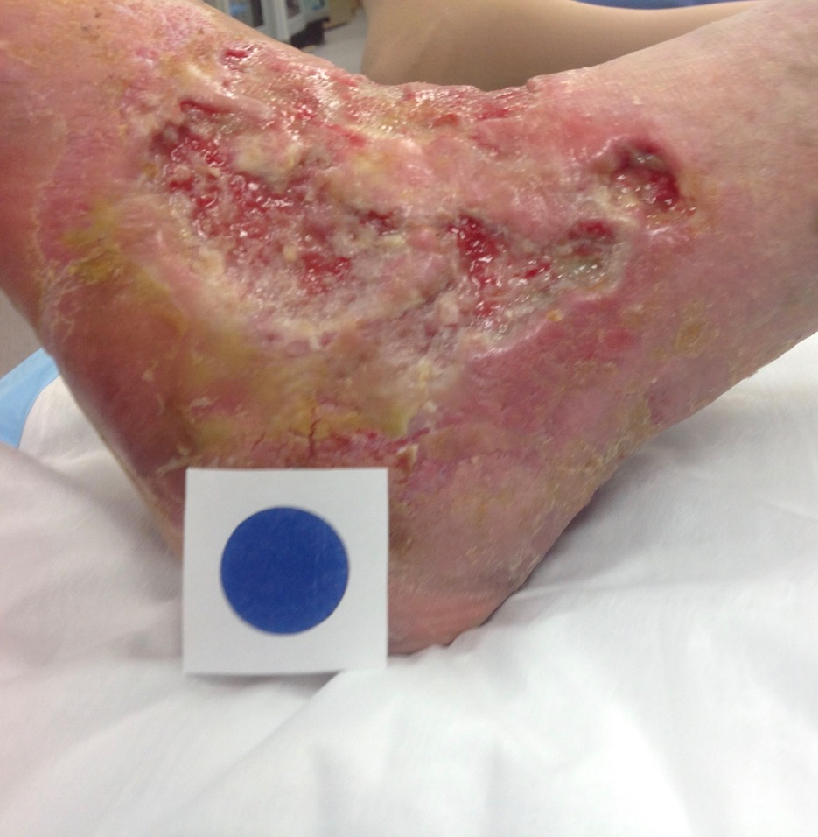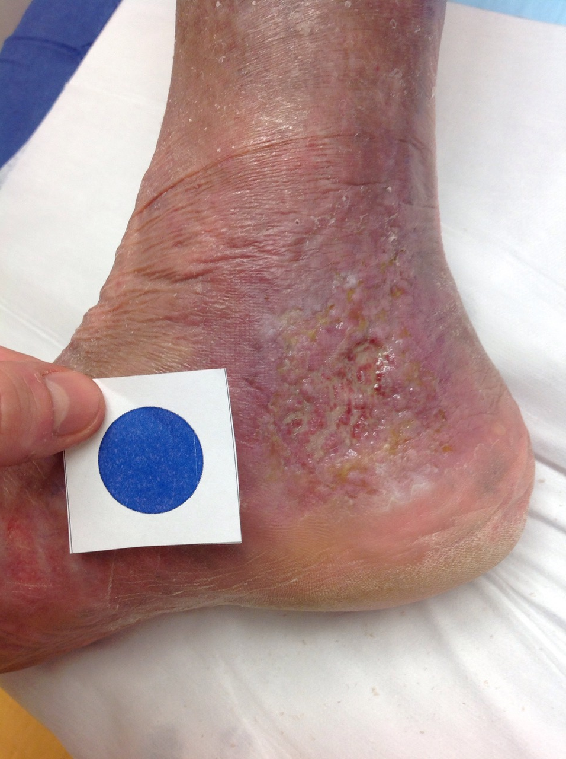

The success and importance of the clinic and the education program was recognized in 2014 by the then Minister for Health, Mr. Peter Dutton, when named runner up in the National Lead Clinicians Forum “Awards for Excellence in Innovative Implementation of Clinical Practice”
In addition in December 2016 the Gold Coast Clinician’s Challenge organised by the Gold Coast Clinician’s Group and supported by the Gold Coast Primary Health Network awarded first prize to Wound Busters in the New Idea category for the project to establish chronic wound clinics with associated GP/ nurse education around Australia
Powerful evidence of the role of a secondary primary care clinic lies with the figures that the Clinic was shown in the Gold Coast Integrated care project to have saved the Gold Coast University Hospital $880,000 in managing complex patients with post operative wound care. The clinic enabled early discharge, reduced readmission rates, reduced inappropriate antibiotic use and increased patient satisfaction.
The Pilot program concluded in 2016 and to this date only 1 other GP practice has replicated this model of care. This highlights the issue of inadequate financial support by Medicare for a very common medical problem afflicting Australians, i.e. acute and chronic wounds. The impact of the closure of the clinic upon the local community and the tertiary hospital was substantial.
The work of Wound Busters Pty Ltd does continue in the area of education to GP’s and practice nurses throughout Australia via local meetings and workshops, advanced learning modules and national conferences.

References:
BEACH Data University of Sydney. http://sydney.edu.au/medicine/fmrc/beach/data-reports/public/
Carramar Consulting GCHSD Chronic wound management model of care draft final report. December 2009
Charles J. Britt H. Chronic skin ulcers. Australian Family Physician Vol.43 No.9 September 2014
Document: Topical negative pressure in wound management. London: MEP Ltd, 2007.
European Wound Management Association (EWMA). Position Document: Understanding compression therapy. London: MEO 2003
European Wound Management Association (EWMA). Position Document: Identifying criteria for wound infection. London: MEP Ltd, 2005.
European Wound Management Association (EWMA). Position Document: Management of wound infection. London: MEP Ltd, 2006. European Wound Management Association (EWMA). Position Document: Hard- to-heal wounds: a holistic approach. London: MEP Ltd 2008.
Ge Zhao et al. Biofilms and Inflammation in Chronic Wounds.Adv Wound Care(new Rochelle). 2013 Sep; 2(7): 389-399 https://www.ncbi.nlm.nih.gov/pmc/articles/PMC3763221/
Graves N, Zheng H. The prevalence and incidence of chronic wounds: a literature review. Wound
Practice and Research 2014; 22[1]: 14-19.
Graves N, Zheng H. Modeling the direct health costs f chronic wounds in Australia. Wound Practice and Research 2014; 22[1]: 20-33.
James GA. Swogger E. Wolcott R. Pulcini E. Secor P. Sestrich J. Costerton JW. Stewart PS. Biofilms in chronic wounds. Wound Repair Regen. 2008; 16:37. [PubMed]
KPMG An economic evaulation of compression therapy for venous leg ulcers. AWMA 2013
Lam K, Peterson M Ochoa D, Wang A, Shi S, Attar In Vivo-In Vitro Evaluation of Bacteria Aerosolisatiom During Treatment with Acoustic Pressure Wound Therapy for Infected Wounds e Poster ¹BRIDGE PTS (Preclinical Testing Services). San Antonio, Texas; ² Celleration Inc, Eden Prairie, Minneosota.
Margolis S. Chronic leg wounds and ulceration:an ongoing challenge. Australian Family Physcian Vol43.No.9 September.2014
Serena T, Kwon Lee, Kan Lam, Attar P, Meneses P, Ennis W. The impact of noncontact, non thermal, low frequency ultrasound on bacterial counts in experimental and chronic wounds. J Ostomy Wound
Management. 2009.
Sussman G. Ulcer dressings and management. Australian Family Physician Vol.43, No.9September 2014.
Leaper DJ, Schultz G, Carville K, Fletcher J, Swanson T, Drake R Extending the TIME concept- What have we learnt over the last 10 years? International Wound Journal.2012, Dec 9. Supple.2:1-19
RandoT. Evaluation of 2 different low frequency ultrasound Debridement Devices in a Community Based Wound Clinic. ePoster, Wounds Australia Conference, 2016. Melbourne.
Sinha S. Management of venous leg ulcers in general practice – a practical guideline. Australian Family Physician Vol 43, No 9 September 2014.
Whitlock et al, Wound care costs in General Practice.Vol.43, No.3, March 2014pp143-146 http://www.racgp.org.au/afp/2014/march/)
Ulcer and Wound Management Expert Group. Therapeutic Guidelines:ulcer and wound management. Melbourne:Therapeutic Guidelines Limited;2012.
World Union of Wound Healing Societies. Principles of best practice: Minimising pain at wound dressing-related procedures. A consensus document. London: MEP Ltd, 2004. Available from URL: http://www.wuwhs.org.
Margolis S. Chronic leg wounds and ulceration:an ongoing challenge. Australian Family Physcian Vol43.No.9 September.2014
Williams T, Alston D, Miexna A, Conner Kerr T. Effects of 35kHz on aerosolisation of bacteria. http://www.o-wm.com/content/24th-annual-spring-symposium-advanced-wound-care-and wound-healing-society meeting-0 2016
YellandS. General practice and primary care:making a difference at the coalface of wound management in Australia.Wound Practice and Research.Vol22No.2-June2014

