Known Ambu Blue Sensor M Electrode Contact Issue

With the QRS ECG, many people use the Ambu Blue Sensor M electrodes. There are two types; one can have the pin put straight into it (left) and the other is a press stud type which requires another clip to hold onto it (right).

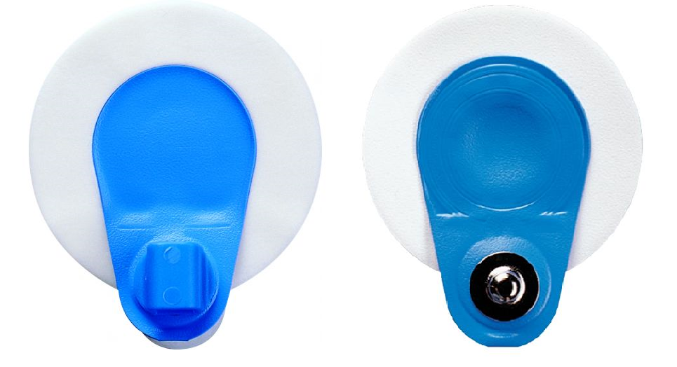

With the one on the left, if the ECG pin is pushed through too far, they often don’t make proper contact and result in there being no trace at all. As per usual, the limb electrodes are the most important; all four MUST make proper contact right through to the patient or you may get no trace at all from the patient.
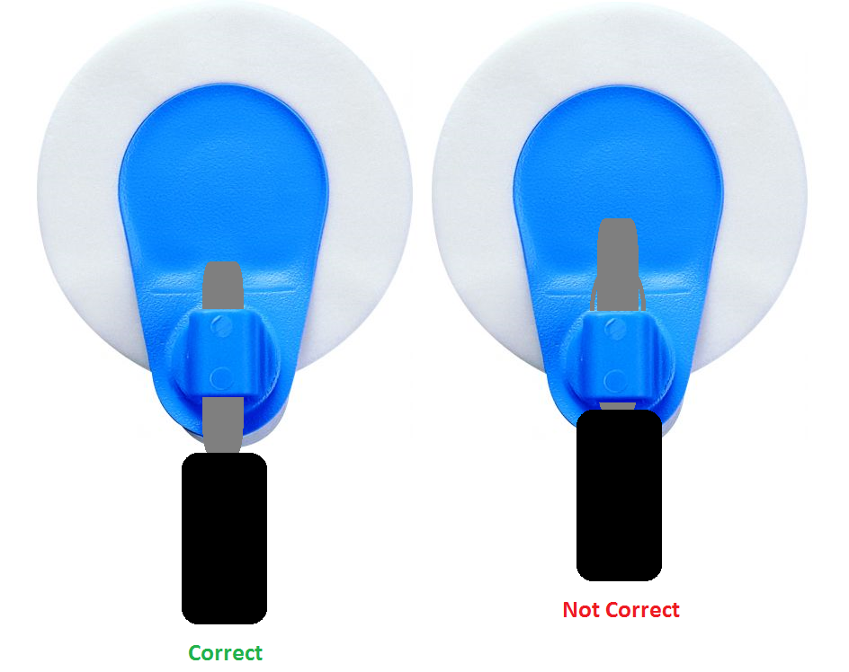

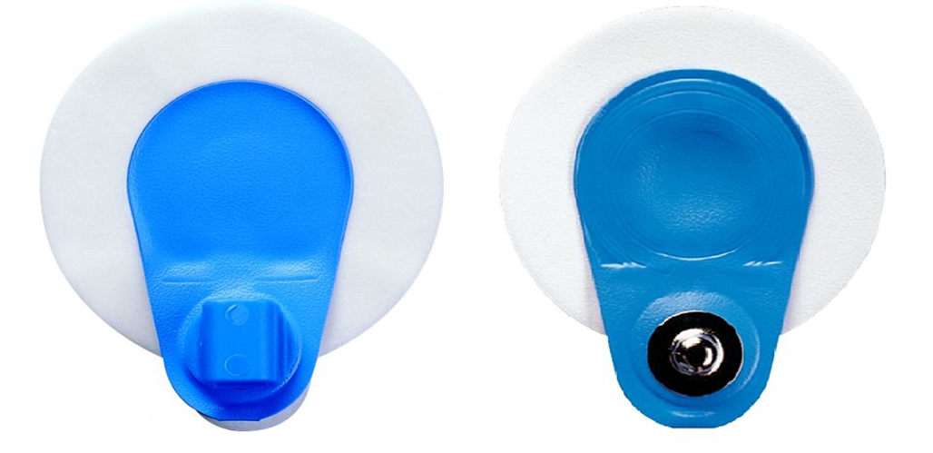

Always press the white seal around the outside to make contact with patient. If you press in the middle Gel will slide from the outside effecting the contact.
Make sure your packets are sealed after each use with a bulldog clip. Do not take them out of the packet to store. They are Alfoil packets to keep their freshness. So please close after use.
Applies to all ECG Electrodes.

